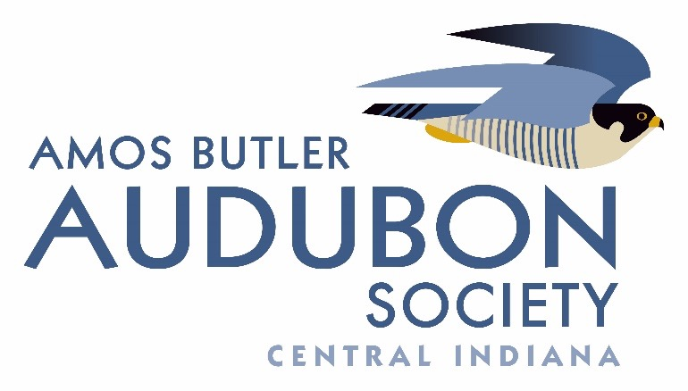

Amos Butler Audubon Society Birdathon Grant Funding Guidelines

Amos Butler Audubon Society (ABAS) provides funds for projects supporting the organization’s mission of promoting the enjoyment and stewardship of the birds of Central Indiana.

Birdathon grants are typically in the range of $500 to $5,000 with most in the $1,000 to $2,000 range. However, for major projects larger, amounts may be considered. To be
considered for funding, your proposal must focus on birds, and address at least one or more of the following:
- Research projects related to birds of Central Indiana
- Public education related to birds of Central Indiana
- Enjoyment of the natural environment related to birds of Central Indiana
- Stewardship of the natural environment related to birds of Central Indiana
- Preservation or restoration of natural habitats in Central Indiana or habitat that is important to the birds of Central Indiana

Please note ABAS Birdathon grants do not typically support requests for birdseed, food, snacks, refreshments, reimbursement, or per diem expenses. Other exclusions and exceptions may be determined on a case-by-case basis.
Your proposal should be submitted (electronically and hard copy) on your organization’s letterhead and be signed by the chief executive officer or the equivalent. Your proposal must be no longer than three single-spaced pages (12pt. font). The deadline for online submissions is
February 25 at 5:00 pm EST. Hard copies must be postmarked by February 25.

Proposals should be submitted to:
Donna McCarty
ABAS Birdathon Grants Coordinator
5520 Spindle Tree Rd
Indianapolis, IN 46268
donnalmccarty@me.com

Begin your proposal with the following bullet points:
- Organization name
- Proposal title
- Amount requested
- Brief summary

Then write the narrative to include the following:
- A brief description of your organization.
- Have you received funding from ABAS previously? If so, explain.
- A clear description and evidence of the need your request is intended to address. Be explicit regarding which of the five aspects of the ABAS mission you are addressing.
- A description of how you will address this need.
- Supply sufficient detail to allow us to assess the feasibility of your project.
- Provide a timeline for your project.
- Why is your organization the appropriate group to meet such needs?
- What are your plans for long-term funding and/or maintenance of the proposed project?
- What other sources of funding have you secured?
- What measurable results will you report to ABAS?
- How many people (organisms, acres, etc.) will be served?
- How will ABAS be recognized? (e.g., signs, press releases, news articles, etc.)
- Detailed budget with justifications (not part of the three-page limit)

If you receive funding from ABAS, you will be required to submit a project progress report by January 31 of the following year including details on the use of funds and measured results. More information about preparing this report will be supplied upon your receipt of the funds.

